电放保函（L/G）

致：中国扬子江轮船股份有限公司
TO: CHINA YANGTZE RIVER SHIPPING CO., LTD

对于以下所述货物：
（WITH REGARDS TO BELOW MENTIONED CARGO:）
VSL: XIN MING ZHOU 20 VOY: 1631E B/L NO: YZJ1631ESHIH063
POD/VIA: INCHON
SHIPPER: H&D LOGISTICS LTD
CNEE (OR RCVR): UNICO EXPRESS CO.,LTD.

我司在此向贵司呈交该货物全套正本提单，保证提单的背书全部连续有效，并申请贵司无正本提单放货给以上收货人，我司将承担无正本提单放货而产生的一切风险，责任和损失。
凡因此无正本提单放货产生的任何争议，均应交中国海事仲裁委员会，按照该委员会的现行仲裁规则在上海进行仲裁。仲裁裁决是终局性的，对各方当事人均有约束力。
WE HEREWITH SURRENDER THE FULL SET OF O B/L FOR THIS CARGO WITH FIRM GUARANTEE THAT THE ENDORSEMENT (S) ON THE B/L IS ALL CONTINUOUSLY VALID. YOU ARE KINDLY REQUESTED TO RELEASE THIS CARGO TO A/M CNEE. ALL RISKS, LOSSES AND LIABILTIES IN CONNECTION WITH THE RELEASING OR ARISING THEREAFTER WILL BE BORNE BY US.
ANY DISPUTE ARISING OUT OF OR IN CONNECTION WITH THIS RELEASING SHALL BE SUBMITTED TO CHINA MARITIME ARBITRATION COMMISSION FOR ARBITRATION IN SHANGHAI IN ACCORDANCE WITH THE EXISTING ARBITRATION RULES OF THE COMMISSION. THE ARBITRATION AWARD SHALL BE FINAL AND BINDING UPON ALL THE PARTIES.
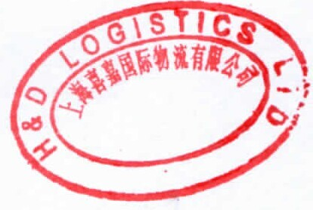
发货人签字（公司盖章）
SHPR’S SIGNATURE (WITH COMPANY STAMP)
货运代理人盖章（FORWARDER’S STAMP） _
日期（DATE）： 2016 年 7 月 26 日

该保函中如有中英文解释不同，将以中文为准。
（IN THE EVENT OF DISCREPANCY BETWEEN THE INTERPRETATION OF THE CHINESE AND ENGLISH EDITION, THE CHINESE EDITION SHALL PREVAIL.）

